CYBERCAMP SUCCESS
UT Dallas and the Cyber Defense Labs, raise the bar.
As a new school year starts sixty-five students and four teachers return to their own schools ready to lead new Cyber Patriot Teams. These individuals gave up four weeks of their summer to participate in intense, hands on program to get them ready for this season’s Cyber Patriot Competition. Students were grouped into 5 or six person teams and given a veteran Cyber Patriot Competitor as a team leader. Students came from all over the country to attend this camp, traveling form places like Los Angeles, Chicago, and De Moines to spend a month in Dallas.

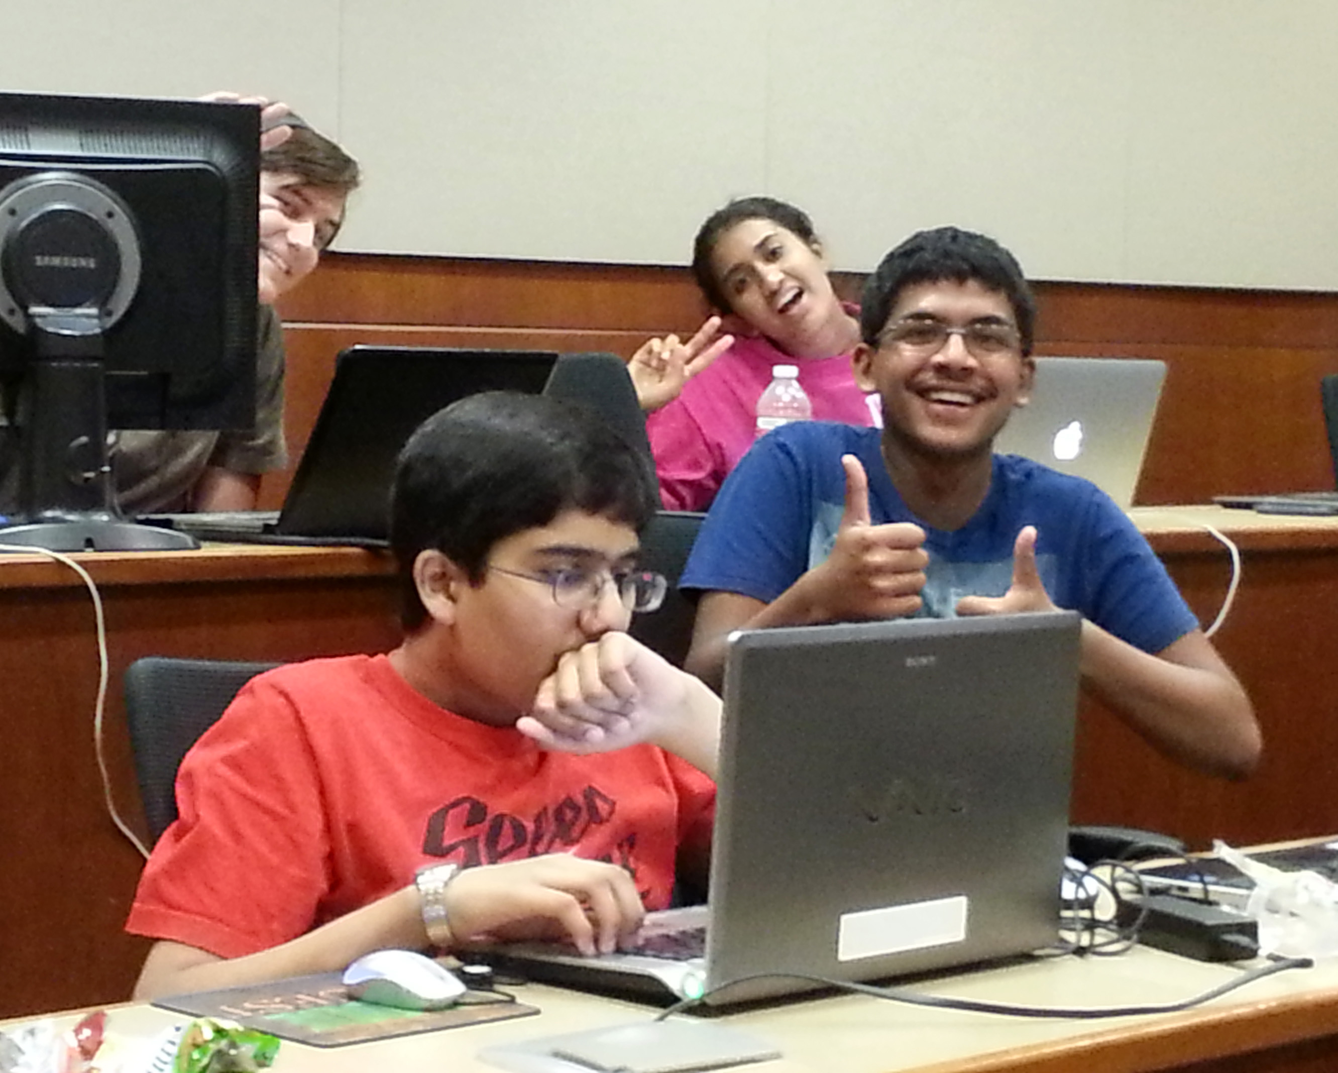
Each day would begin at 9 am sharp with a forty-five minute lecture delivered by one of the team leaders. Then the practical labs started. Five hours later, it was time for the teams to deliver presentations about how they met that day’s lab challenges. Subjects include every facet of Cyber Patriot Competition and more. Included were labs on hardware, networking, Cisco command line Interface routing, Malware extraction, Active Directory Administration, Serve roles, Ubuntu automation, regedit and windows hardening. In addition to these 17 challenging days of labs all students and teachers completed 2 Cyber Patriot Exhibition rounds, most achieved perfect scores on the Windows round and high scores on the Ubuntu image. This however is not the end of their training UT Dallas and the Cyber Defense Center will be holding training events for all interested teams in the North Dallas area.

